Unit III: Overview of Medical Microbiology: Important fungal diseases-Superficial, Subcutaneous, Systemic and Opportunistic Mycoses
Fungal infections are Mycoses. Most pathogenic fungi are exogenous, their natural habitats being water, soil and organic debris. The mycoses with highest incidence – candidiasis and dermatophytosis- are caused by fungi that are part of the normal microbial flora or highly adapted to survival on the human host.
For convenience, mycoses may be classified as-superficial, subcutaneous, systemic and opportunistic mycoses (Table 45-1). Grouping mycoses in these categories reflects their usual portal of entry and initial site of involvement. Superficial mycoses are superficial infections of the epidermis, hair, and nails. 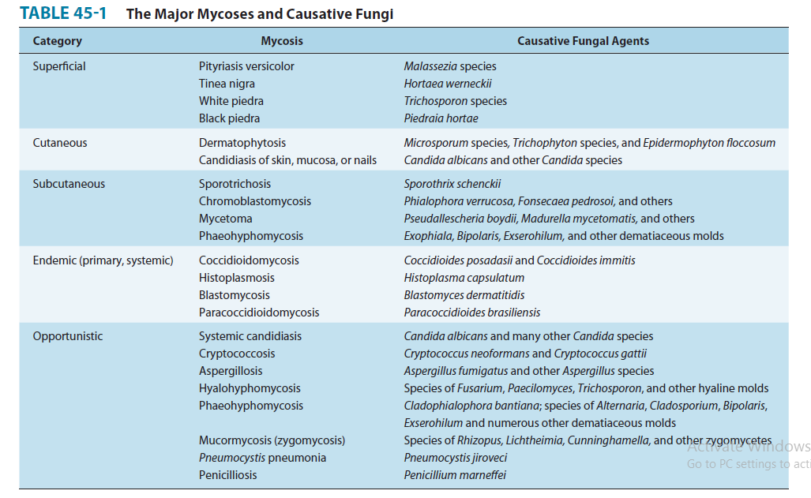

Subcutaneous mycoses that penetrate the epidermis and the dermis to infect deeper tissues. Systemic Mycoses that spread throughout the body are called systemic mycoses.
However, there is considerable overlap, since systemic mycoses can have subcutaneous manifestations and vice versa. Most patient who develop opportunistic infections have serious underlying diseases and compromised host defenses, and also infect immunocompetent individuals.
Superficial Mycoses- Superficial mycoses are superficial infections of the epidermis, hair, and nails. Table 32.1 listed some of the fungi that cause superficial mycoses, collectively theses pathogens are called dermatophytes.
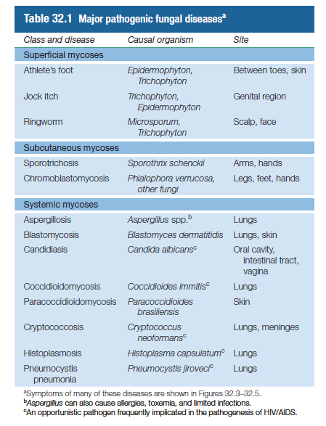

In general, superficial mycoses can be troublesome and occurring often infections, but are not serious health concerns. Fungi such as Trichophyton (figure 32.1b) cause infections of the feet (athlete’s foot) and other moist skin surfaces, and are quite common (figure 32.3a). These infections cause flaking and itchy skin and are easily transmitted by the cells or spores of the pathogen present in contaminated shower stalls, gymnasium and locker room floors, contaminated shared articles such as towels or bed liners, or from close person-to-person contact.
Related surface mycoses include “jock itch”, an itchy infection of the groin, skin folds or anus and ringworm (Table 32.1). Despite the name, ringworm is a fungal infection, typically localized to the scalp or the extremities; the infection causes hair loss and inflammation
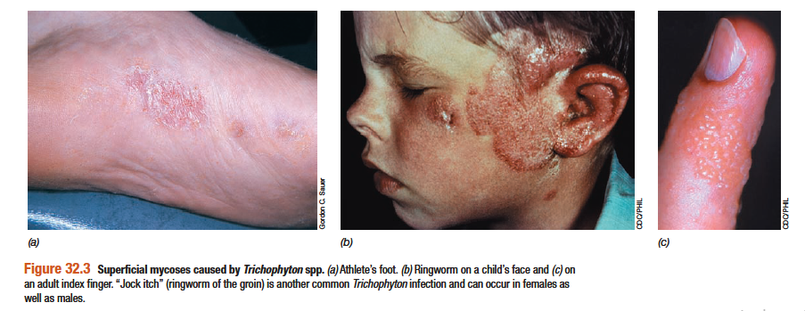

Treatment- Superficial mycoses can be treated with topical antifungal creams or liquid aerosols, although prophylactic application on a long term basis may be necessary if constant exposure to the pathogen.
Subcutaneous Mycoses- Subcutaneous mycoses that penetrate the epidermis and the dermis to infect deeper tissues. Or Subcutaneous mycoses are fungal infections of deeper layers of skin than those of the superficial mycoses (Table 32.1).
One disease in this class is sporotrichosis (Figure 32.4a), an occupational hazard of agricultural workers, miners, gardeners and other who come in contact into close and continual contact with the soil.
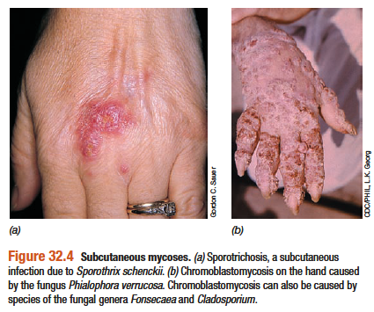
The causal organisms, Sporothrix schenchii (Figure 32.1d), is a ubiquitous soil saprophyte whose spores can enter through a cut or abrasion and infect subcutaneous tissues (Figure 32.4a).
Chromoblastomycosis is due to pathogenic fungal growth in both surface (cutaneous) and subcutaneous skin layers, forming crustly, wartlike lesions on the hand (Figure 32.4) or leg.
Treatment- Both sporotrichosis and chromoblastomycosis can be treated with oral administration of azoles.

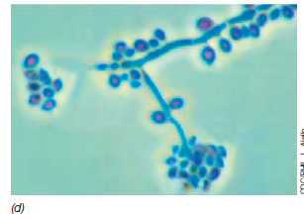
Figure 32.1 Pathogenic fungi – (d) Sporothrix schenckii mycelia and condia

Systematic Mycoses - Systemic Mycoses that spread throughout the body are called systemic mycoses. Systematic fungal pathogens normally live in soil, and humans become infected by inhaling airborne spores that later germinate and grow in the lungs. From there the organism migrates throughout the body, causing deep-seated infections in the lungs and other organs and in the skin.
Histoplasmosis (Figure 32.5a) is caused by Histoplasma capsulatum (Figure 32.1e), and coccidiomycosis (Figure 32.5d) is caused by Coccidiodes immitis (Figure 32.1f).
Cryptococcois (Figure 32.5c), caused by the dimorphic yeast Crptococcus neoformans (Figure 32.1a), can occur in virtually any organ of the body and is the major mycosis seen in HIV/AIDS patients. The dimorphic yeast Candida albicans (Figure 32.1c) is often present as a minor component of the human normal flora. However, this fungus can cause a variety of diseases including mild vaginal infection, more serious oral infections such as thrush (Figure 32.5f), and systemic infection of virtually any organ in those with HIV/AIDS.
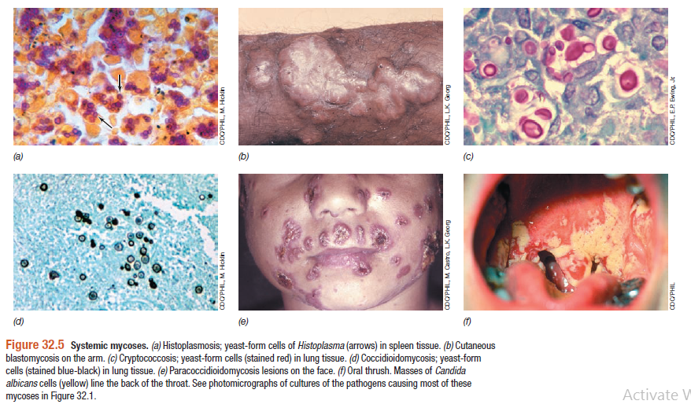
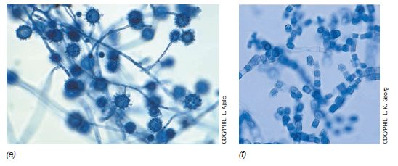
Figure 32.1 Pathogenic fungi- (e) Histoplasma capsulatum mycelia and conidia and (f) Coccidioides immitis conidia.
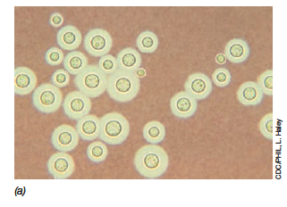
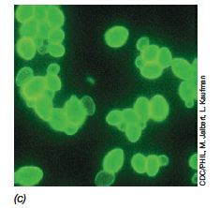

Figure 32.1 Pathogenic fungi. (a). Crytococcus neoformans yeast cells stained to reveal the capsule.
(c). Candida albicans yeast form stained with a fluorescent antibody.

